GUIDEBOOK FOR DIGITALIZATION OF FOREIGN EXCHANGE APPROVAL CASES

FOREWORD
1.1 Since, banking industries are under increasing pressure to offer high customer service levels and deliver standardized trade services regardless of location, consequently BOK Management (Operations and Support Group) decided to build Hubs in four different locations for centralization of Trade processing and controls, ensuring the best services can be offered to our valued clients.
As an association ambitious bank, we endeavor to add value to our customer supply chain with our digital banking solutions. Our local presence backed by a large correspondent bank network helps us to serve customer needs across the world, along with our Trade team who excels in both international and local banking proficiency.
This initiative significantly enhanced operational efficiency and resulted in cost reduction, improved transparency and led to faster decision making at SBP and BOK Banks

1.2 Digitization:
At first, banks were linked with 'SBP FX Regulatory Approval System (RAS)', which enabled banks to submit FX related cases electronically for regulatory approval of SBP and SBP-Banking Services Corporation (BSC). The system has embedded features of providing transparent case tracking mechanisms through emails to customers and case status information option on SBP website
SBP further extended the facilitation to the business community, whereby the BOK banks developed portals to digitally receive FX cases from their clients for processing

1.3 Advantages:
Digitization has several advantages and benefits mainly include:
- Record will be electronically available.
- Repository records will be available.
- Responsibilities and duties are well defined within the central governing body.
- Decision-making are very direct and clear.
- The central power maintains a large "encompassing interest" in the welfare of the organization and customer it rules since it stands to benefit from any increase.

1.4 Objective:
By offering an integrated standardized platform that’s allows the retention of local customer services, yet provides central management of trade / commercial business, improving visibility and speeding up the execution and improving of TAT (turnaround time) in processing and back office support to Branches holding Foreign exchange license.
As per the best practices followed in the international as well as local banking industry, the BOK Operations and Support Group is envisioned for establishment of the digitization portal.

Digital Platform for FX Cases
Customer Interface – BOK Internet Portal
Customer will Log in from his/her internet-banking interface in order to submit FX cases to authorized dealer

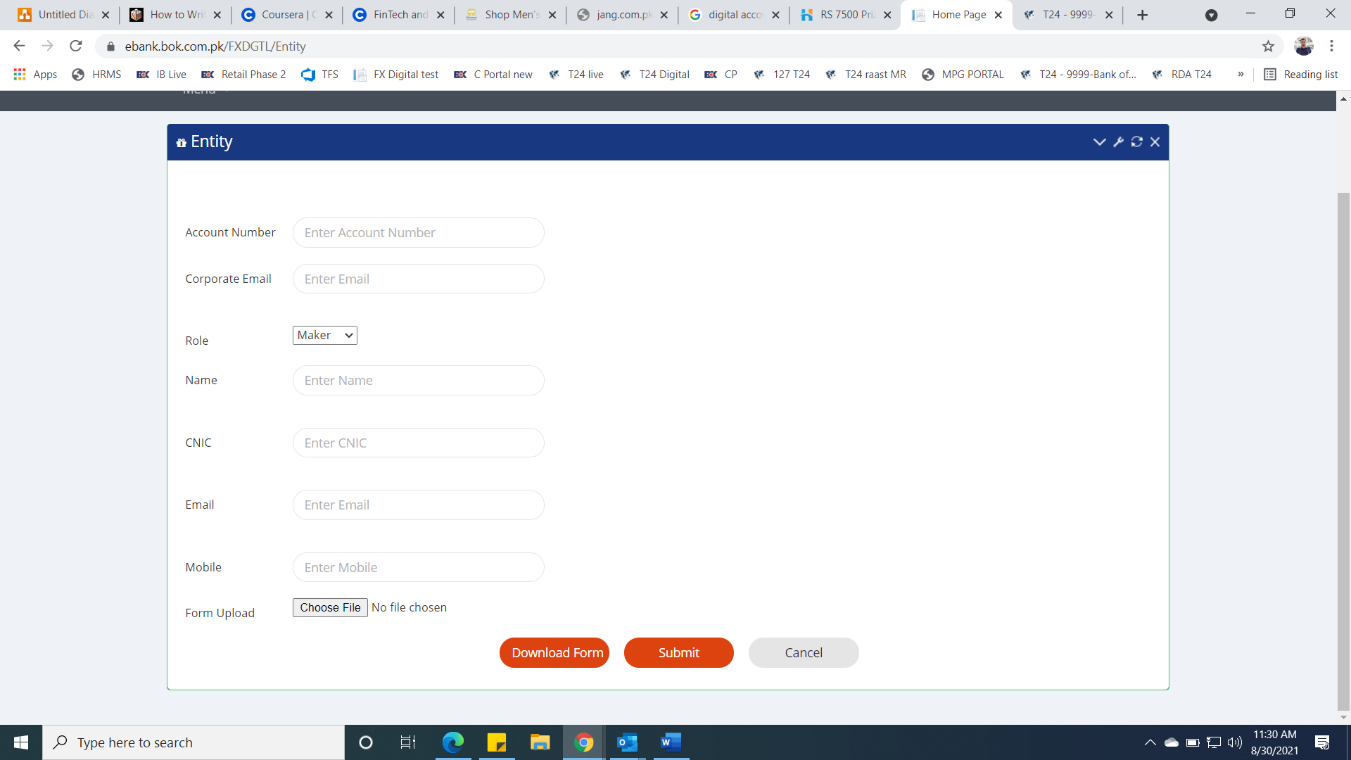

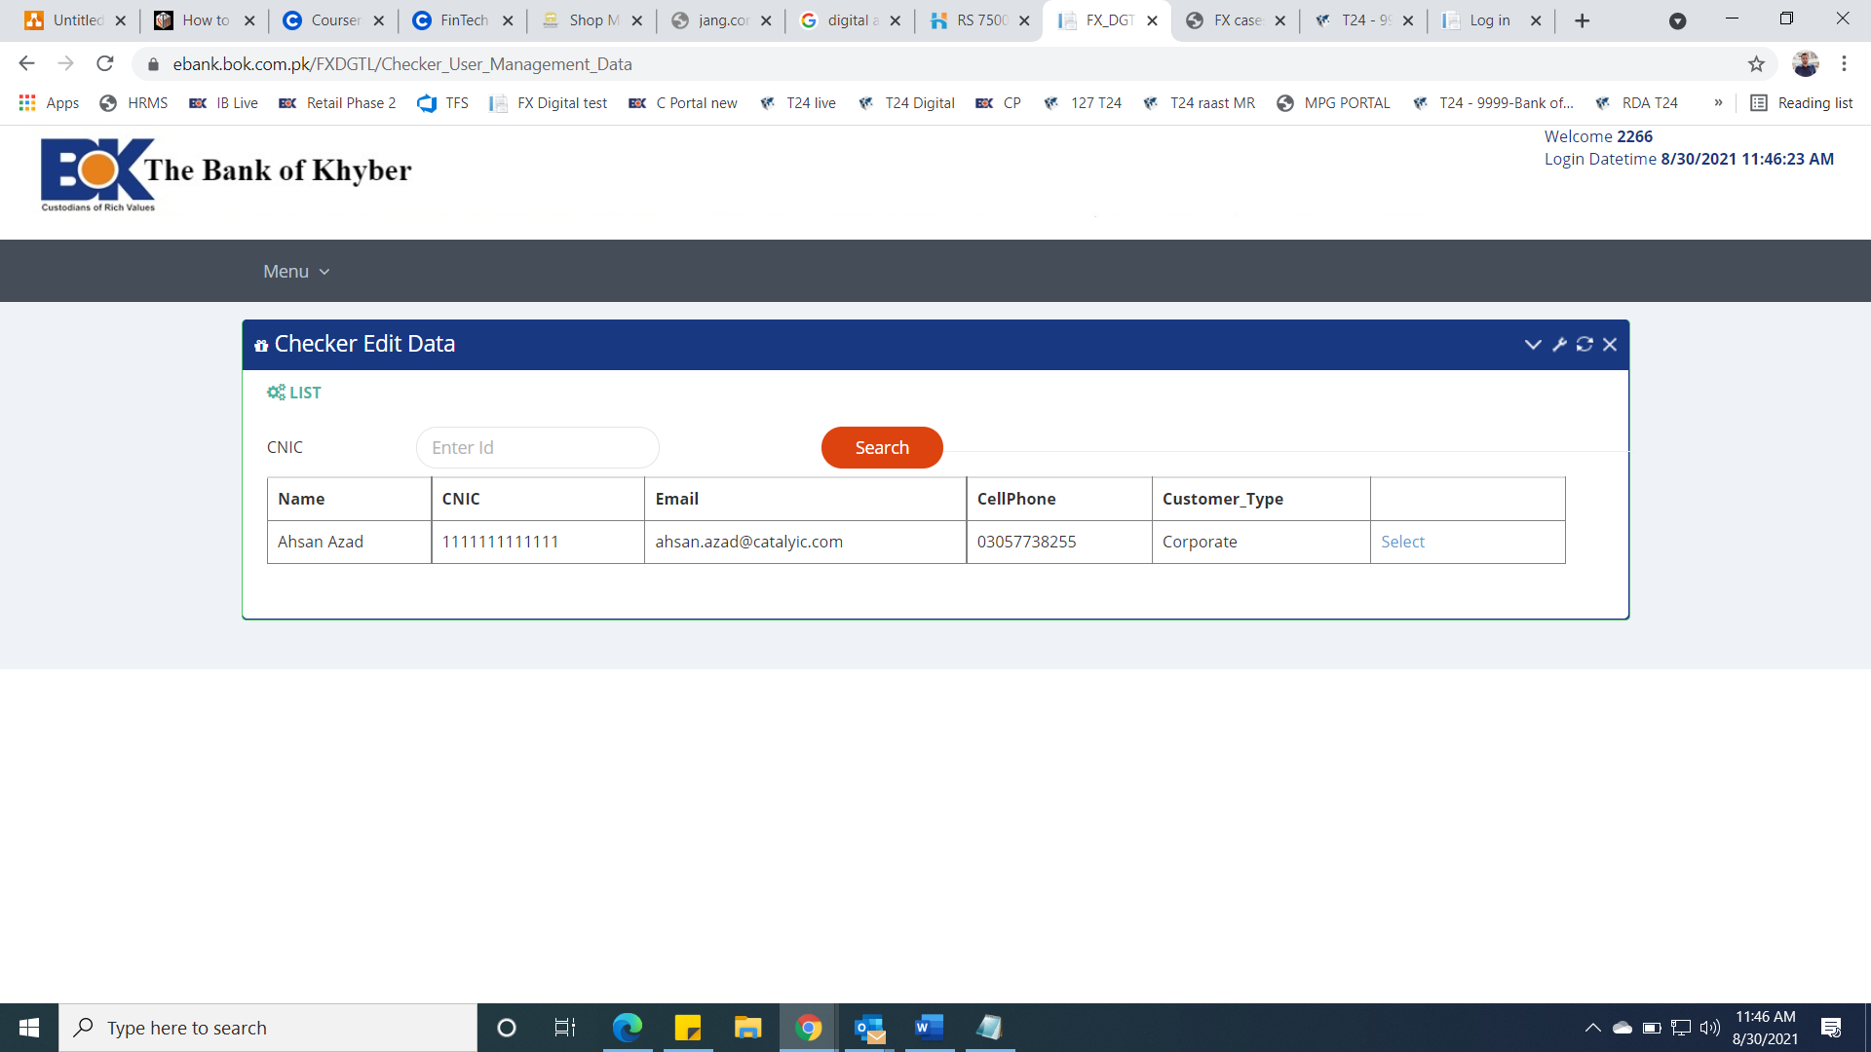

After successful login, customer will click on FX cases to navigate in to the main menu

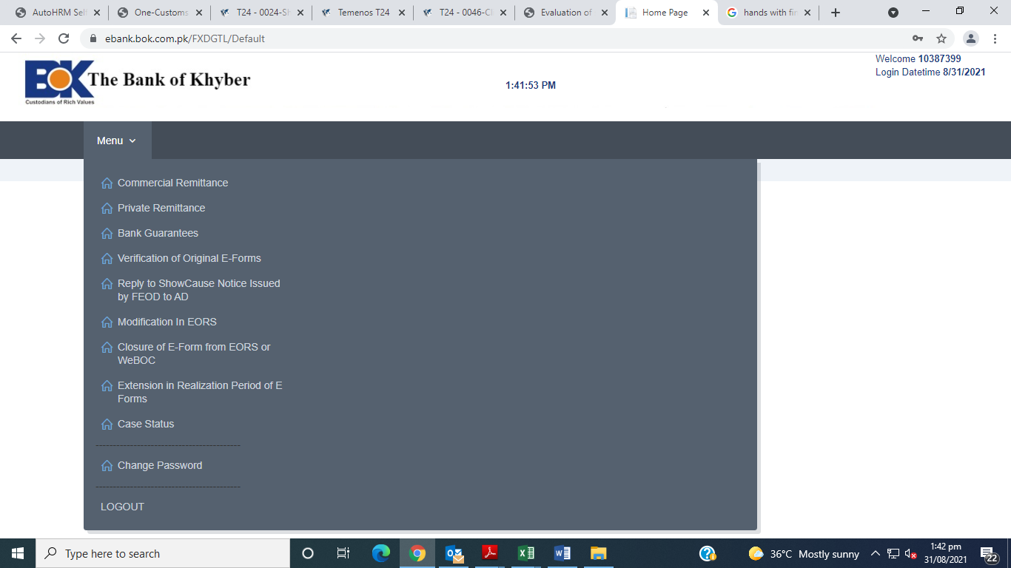

Following screen will appear to initiate new FX cases

And/or click on submit tab for onward submission to the authorized dealer

Following MSG will be reflected after submission of case at portal.

Quote

unquote

Customer can view his/her case status from My Cases menu

